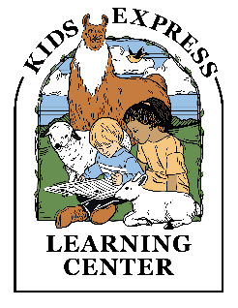
KELC Advisory Committee – January 2020
Meeting Notes

Elementary Curriculum and Info Night Advice. Brainstorm top questions parents would like us to expand on. Questions will be answered at the curriculum and info night.
- How are we going to accommodate kids who need be challenged or need more attention?
- What is our electronics policy?
- Safety measures and policies?
- What additional extracurriculars will be offered, beyond what we offer today? For example, robotics, coding, music, drawing club, etc.
- Long term plan for student-teacher ratios?
- Tuition rates and affordability?
- What is the discipline policy?
- What is the timeline for additional grades and a new building? Where will grades K-3rd grade be taught in the interim?
- What is the projected group size per grade?
- How will the curriculum teach students critical thinking?
- Will students learn about real world issues such as money management, entrepreneurship, etc.?
- What is the homework policy?
- What is your criteria for hiring exceptional teachers?
- What is the credibility of the curriculum being written? Will material reflect current best practices in education and be an expression of a deliberate pedagogical method?
- Can we hear from the elementary teachers to better understand their educational goals and approach? Teachers would also be able to explain the logic behind their grading strategy.
- How will you compete with high standard in academics and producing strong learners?
- Will there be teachers who can champion topics such as math, social studies, and language?
- What technology and materials will be provided to accommodate high quality teaching for our older students in 2020-2021?
Follow up
Organized Sports for Students
- Organized club teams for age 3-year- 3rd grade.
- A subcommittee needs to be formed and will table that request for out February meeting.
- Projected plan to start in the Fall of 2020
Campus Safety (Lights):
- Many new lights have been added or replaced to improve safety and light at night.

2020-2021 School Year Parent Involvement and Community Planning Brainstorm
- Various holiday events for students that integrate into their lesson plans.
- Art Show
- Spirit Week
- Organized room parent volunteers designated for each classroom. Could help with teacher support and social gathering organization
- School play date/picnic before the start of the year to meet other parents and students in the same class.
- Private Facebook groups for classroom parents
- School Sock Hop (potentially to raise funds for a charity)
- Grandparents Day
- Career day or classroom special
- Traditional holiday concert for students to practice performing in a large group.
- Multi-cultural event to learn and celebrate the various cultures of families at the school.
A rough calendar of events will be created and reviewed at the February 2020 meeting. We can then start to assign volunteers who are interested in participating in one or two of these events for next year.

